Tessa Davis

Foundations of Programming-Python

8 March 2022

Assignment 07

Module 07 Knowledge Document

**Assignment**

In this module, we tackled different way of working with (both reading from and writing to) text files, creating operational paths accessible from the Terminal, pickling, writing to and reading from binary files, and structured error handling. This module also emphasized getting more confident navigating with a bit less structure (e.g. filling in gaps with our own research).

**Discussion**

Lab 07-A

After pre-populating the file with numbers, I repeatedly ran into one of two errors as I tried to get the program to read in the values from the mathIn.txt file—either that there were insufficient values with which to run the calculation or a type error. As I understand it, I needed to add lines 96 and 97 (within the read_file function) to split the values in the input file at the comma and convert the values to integers to allow the Simple_Math functions to work property. To read multiple lines into the file, I believe the read.lines() function would allow you to read each line in as a list. You could then draw out the values from the list with indexing.

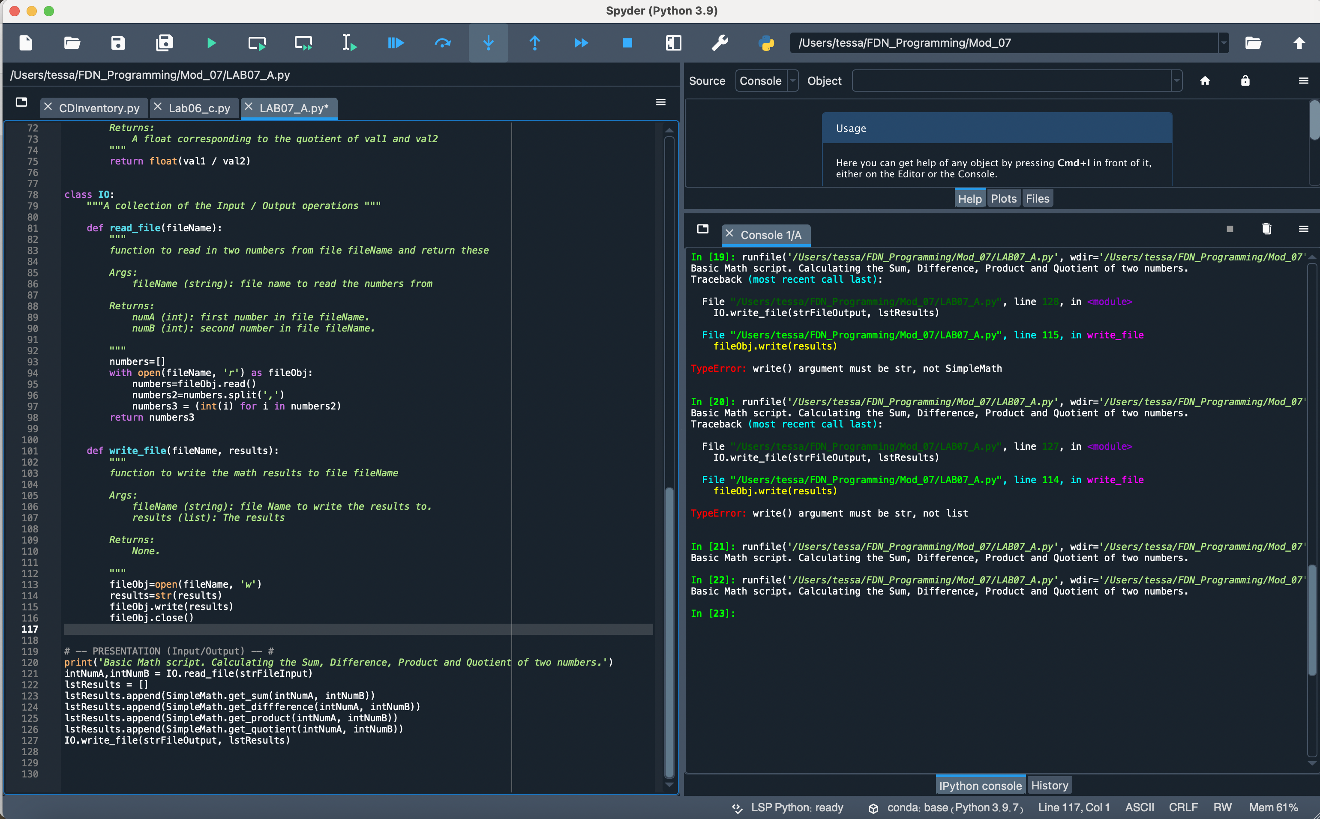

Figure Lab07-A Screenshot

Lab 07-B Working with Binary Files

This lab was definitely a challenge. I struggled with what, precisely, was meant by creating separate operational paths. I initially attempted to create binary files to avoid a file not found error but, even having done so, the code still failed to detect the presence of numbers.dat (I confirmed that it was not a directory disjunct issue so I am unsure as to what the issue was). To get around that issue, I started to go down the line of structured error handling until told not to in our Wednesday class session, Instead, I pulled out the write_file function into separate code to create the file and that seemed to work well. I spent a good deal of time researching the structure and uses of sys.argv and believe I now understand it as a means of calling only a portion of the code in targeted manner while in the Terminal by passing an argument(s) after the code file name (sys.argv[0]).

Figure 02 shows the key changes made to create a working Lab07B script. In IO, I converted the inputs to integers, using numbers_fc to create a list of the ints and then writing those values out by calling the write_file function. That function used the with as loop and pickle.dump to drop the list into the binary file. In ‘calc’, I called the read_file function, defining the input as numbers_imp. I think used indexing to draw out each value and convert to an integer. Those integers were then fed into the Simple_Math calculations.

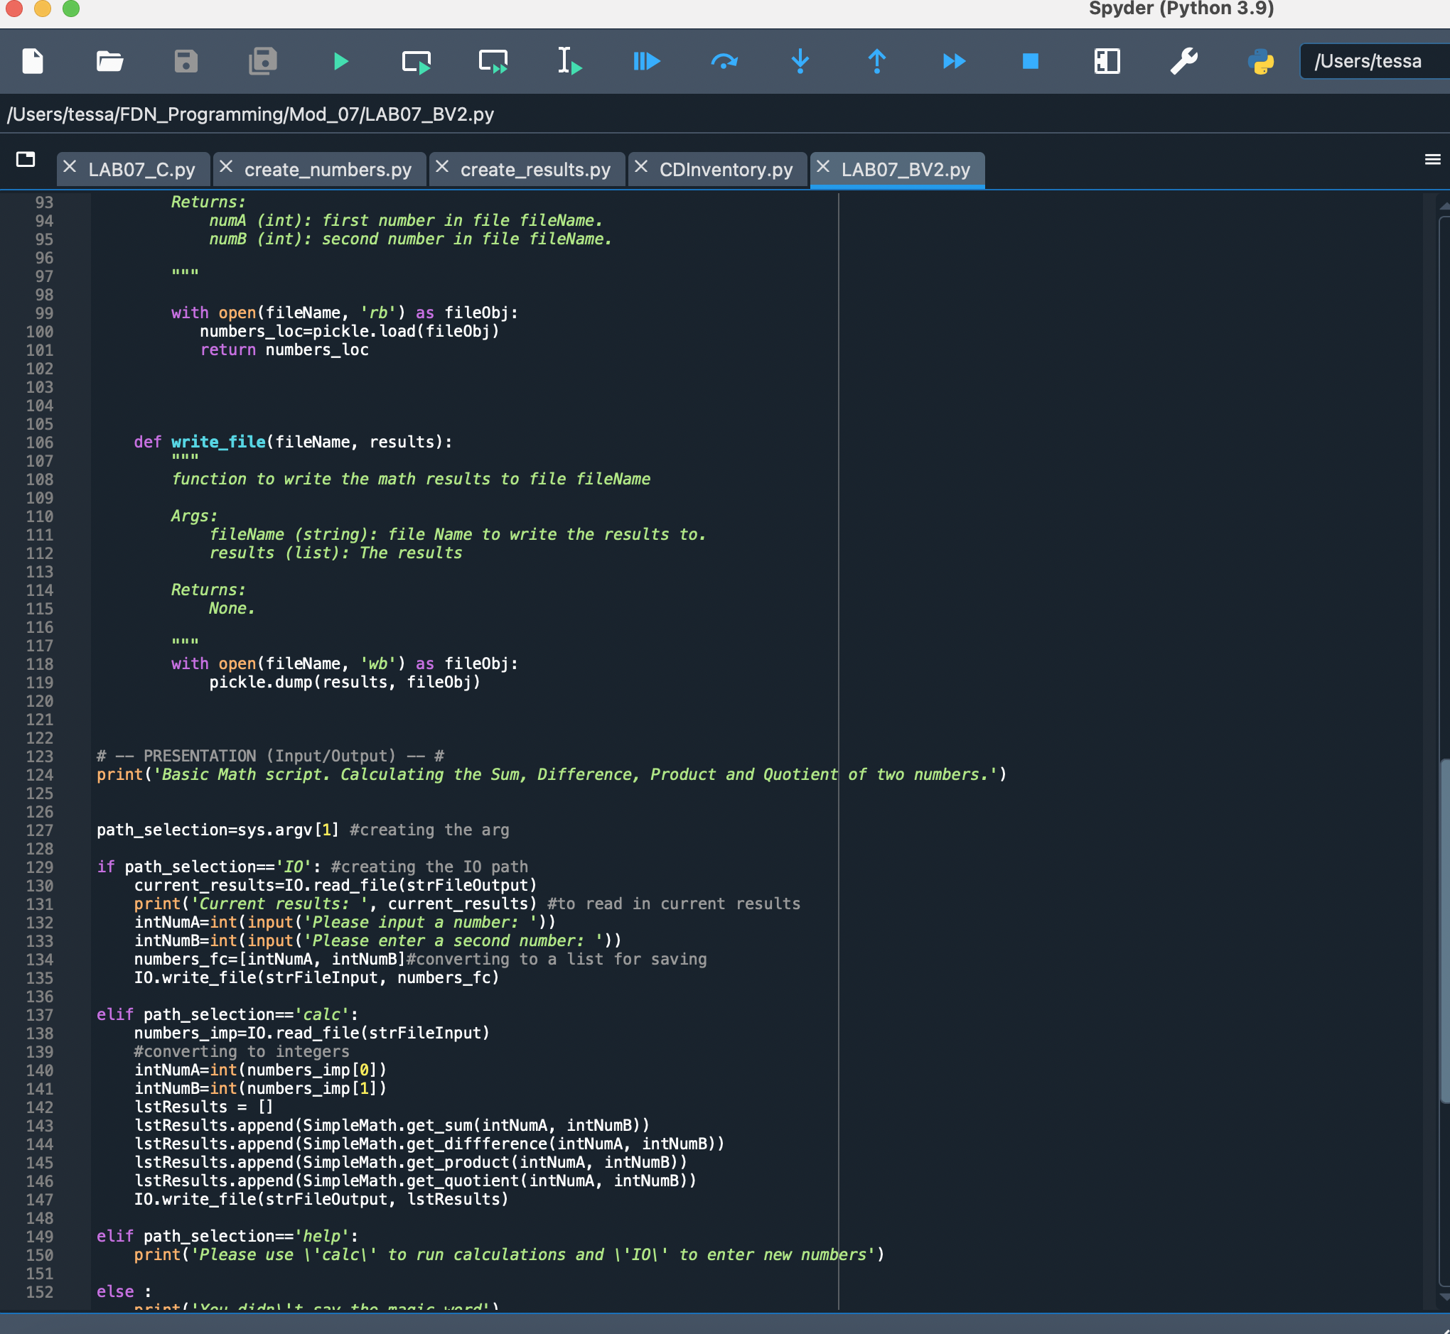

Figure Key Changes to Create Functioning Lab 07-B

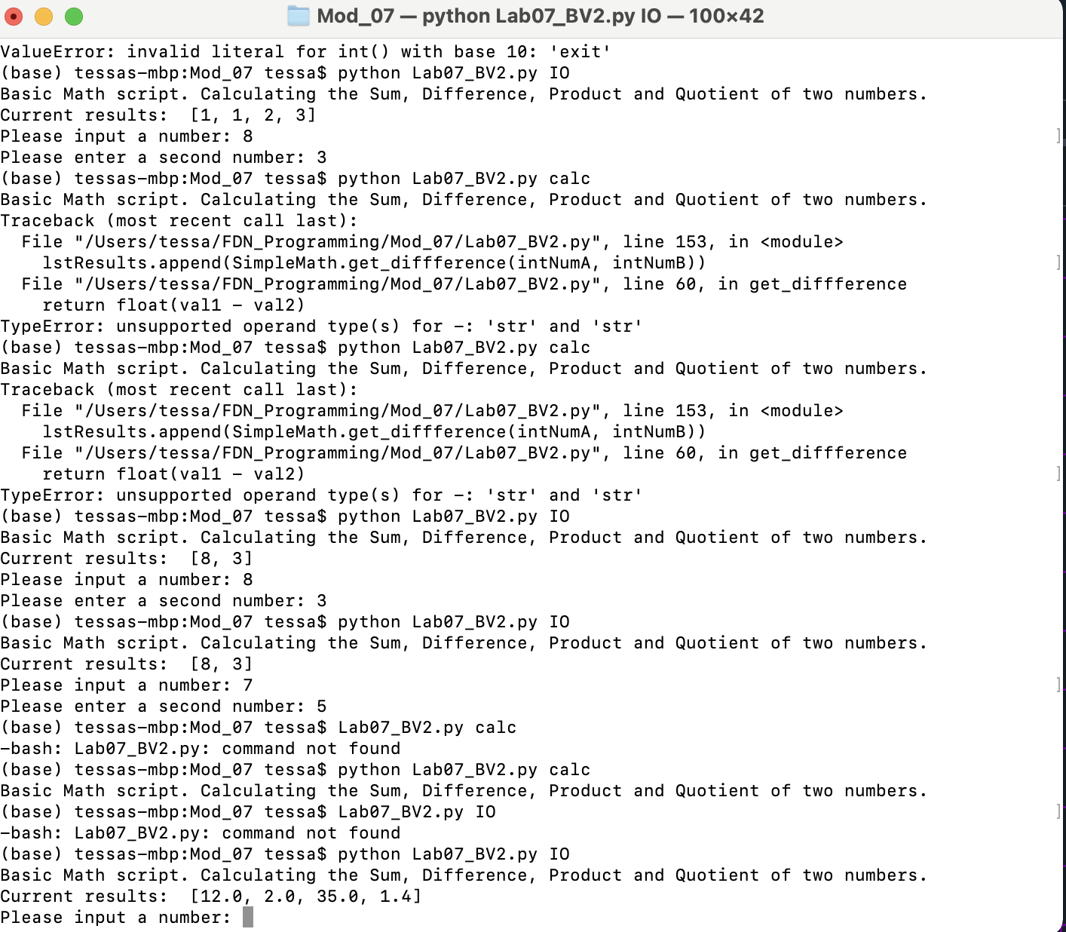

Figure Lab-7-B in Terminal

Additional resources:

<https://www.datacamp.com/community/tutorials/pickle-python-tutorial>

<https://www.reddit.com/r/learnpython/comments/1tmwje/help_indexerror_list_index_out_of_range/>

<https://realpython.com/python-command-line-arguments/#the-sysargv-array>

<https://thepythonguru.com/pickling-objects-in-python/>

Lab07-C Structured Error Handling

I found this lab comparatively easier than Lab07-B. Using while and try-except loops, I was able to control for the possibility that 1) a file with numbers for import did not yet exist, 2) entry of invalid types, and 3) ensuring a non-zero entry for the second number. I built in print statements to guide user input to the correct option (e.g. ‘Please try IO first’).

Additional resource I found particularly helpful: <https://docs.python.org/3/tutorial/errors.html>

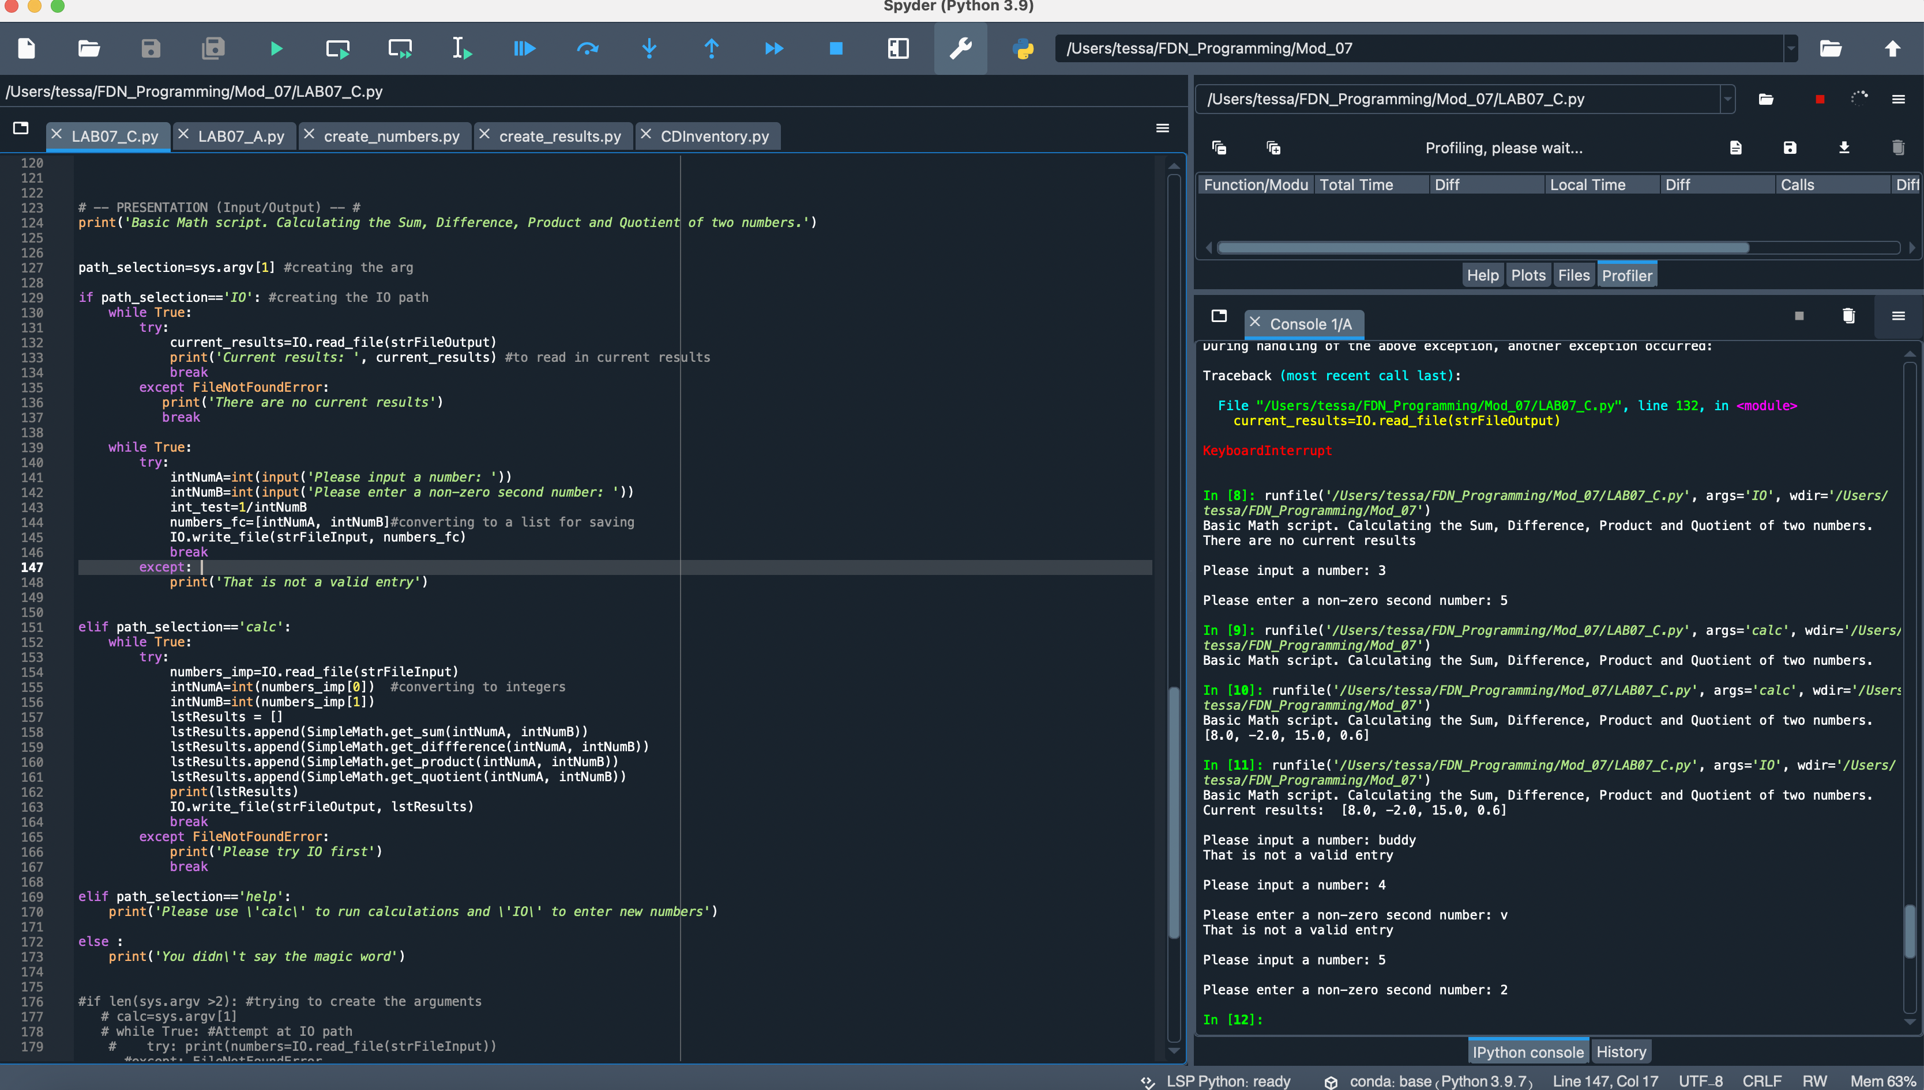

Figure 4 Lab 07C in Spyder

Assignment 07

Once again, I found the error handling reasonably straightforward. The conversion of the file type to binary and the pickling and unpickling that followed threw off the script for a bit. I also ran into a few challenges in trying to ensure that I was using local and global variables correctly (per Laura’s comment on assignment 06). I continue to append the global lstTbl in the create_entry function and did not find any issues with doing so. I would welcome your thoughts on whether this is an ok practice. When I tried to convert to local, my display and add entry code did not work properly—showing only the most recent entry rather than all data that had been loaded in. Because I could not resolve this error, I reverted to the it-works-for-now use of lstTbl in create_entry for the append. Some research suggested that would be correct but I remain unsure. I have captured screenshots of functionality in both Sypder and Terminal. I also confirmed that the .dat file was created. It’s my understanding that the combination of using binary data and pickling and unpickling the 2d lst removed the need for the lines of formatting code previously necessary (e.g. separating out values and joining with a comma for readability).

Regarding error testing and structured error handling, I continued to use the while and tr-except loops. In some areas (noted with pseudocode) I was unable to break the code and determined that no further error handling was required. I once again tried to structure errors to direct the user to the necessary next step, e.g. adding the following print statement in the load inventory eror handling loop: print('\n No CD Inventory currently exists. Try selecting \'a\' from the menu to begin building library').

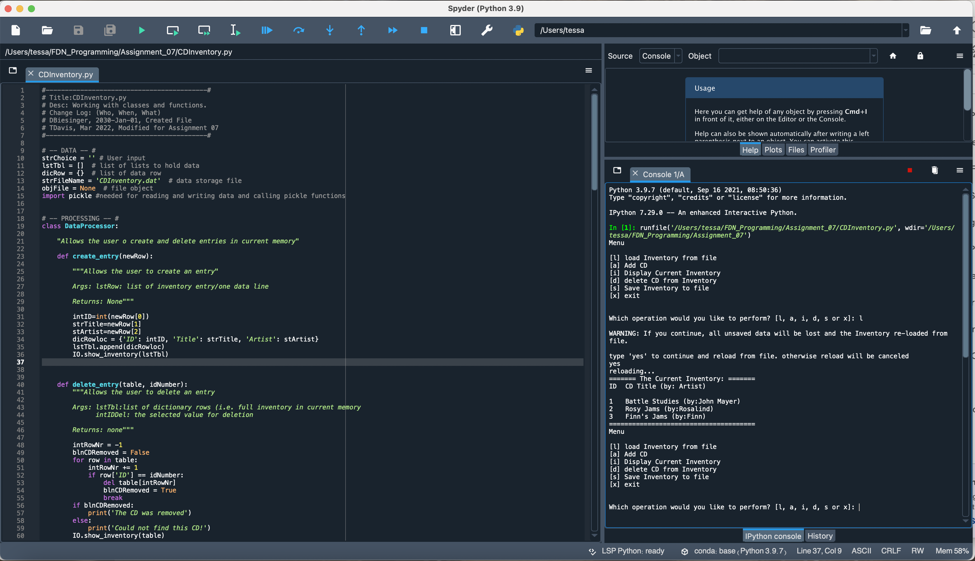

Figure 5 Assignment07 in Spyder

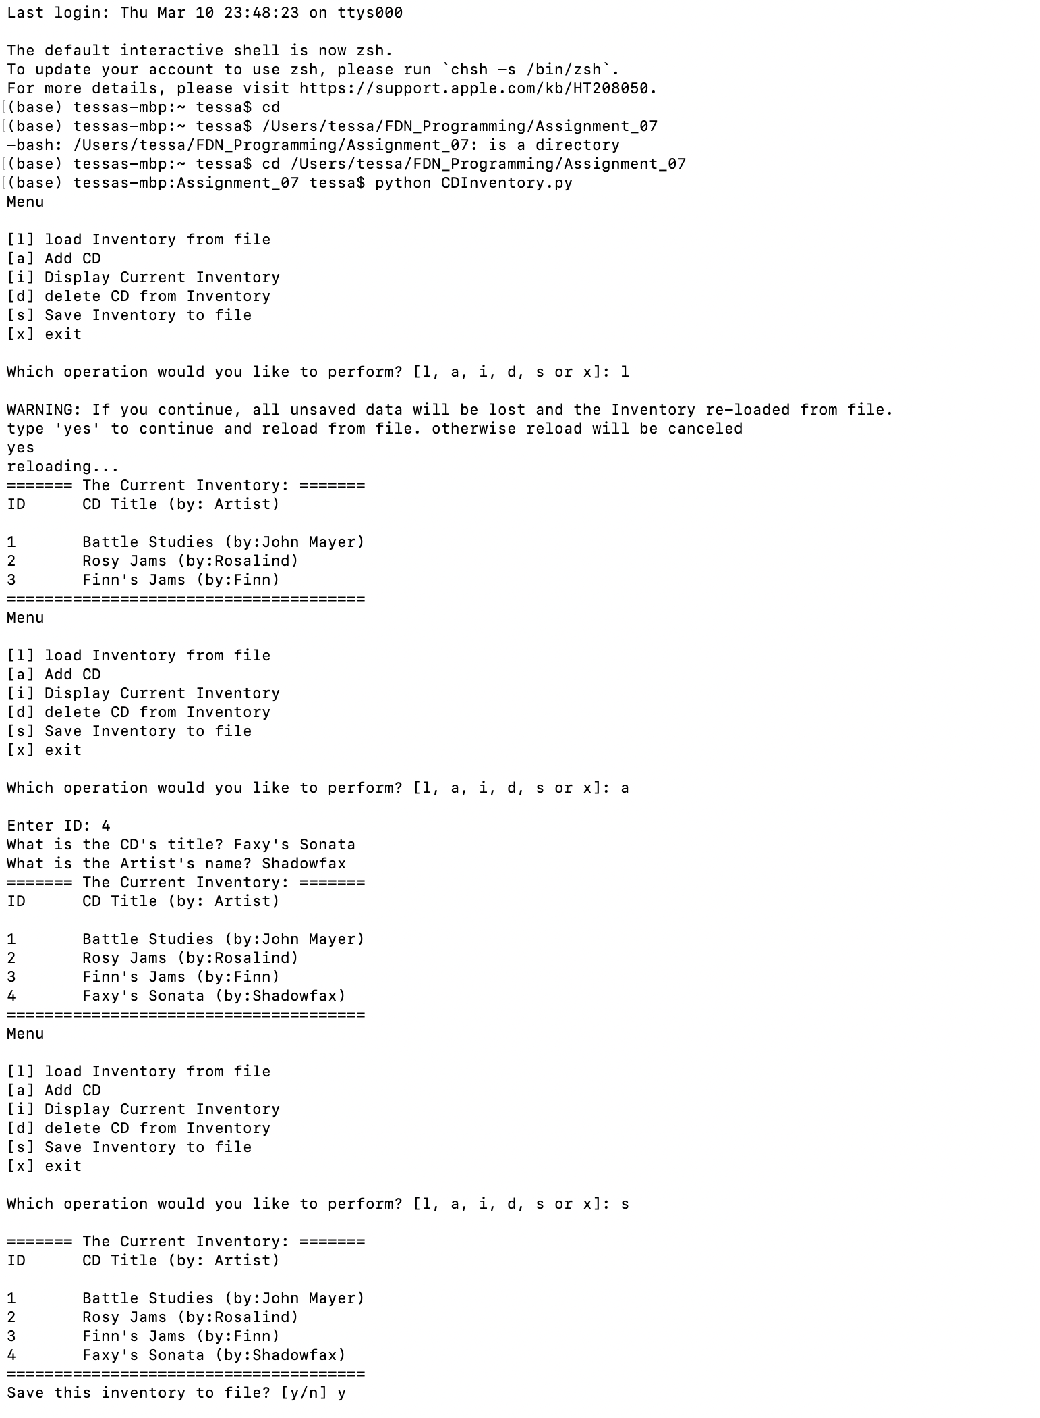

Figure 6 Testing in Terminal

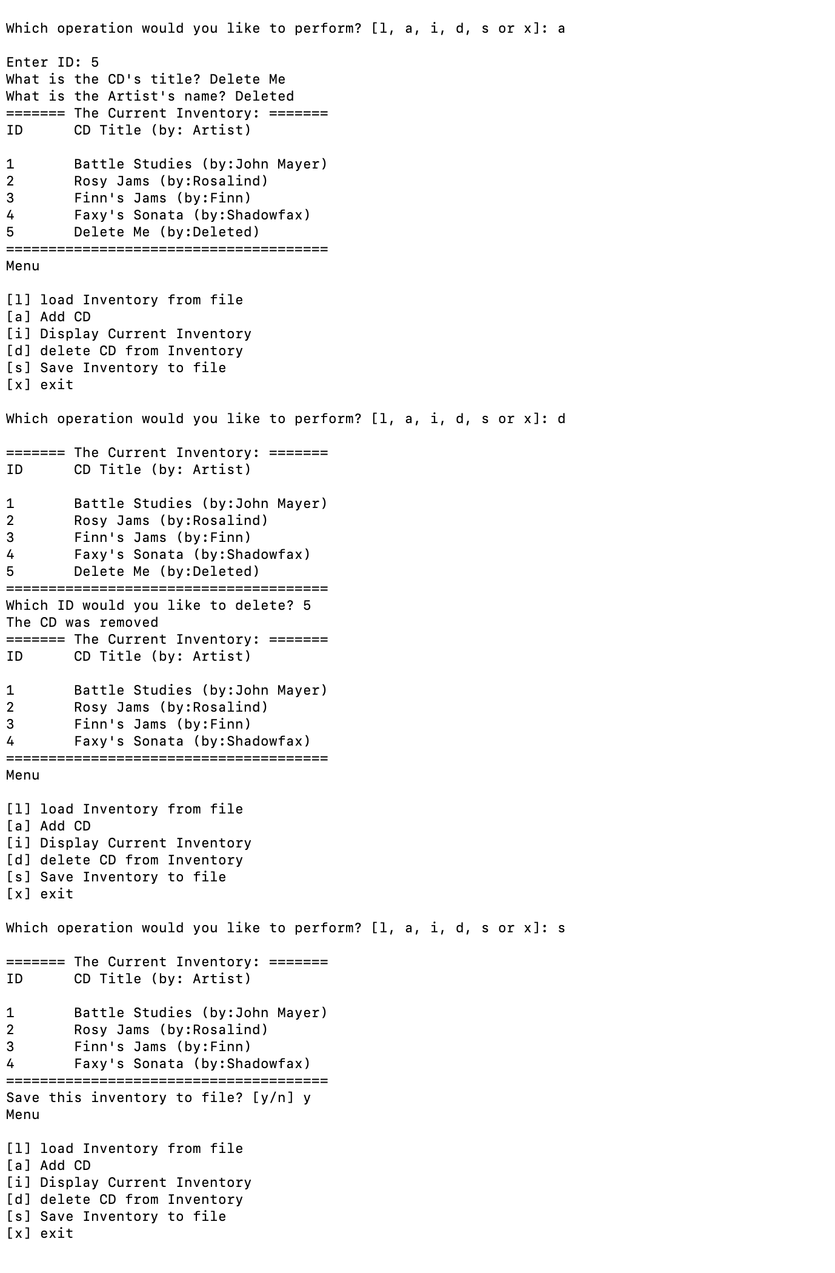

Figure 7 Continued testing in Terminal

**Conclusion**

Once again, this module felt like a step up from the last. I can also, however, see my growth in trouble shooting. Lab07B was the biggest jump in so far as it added a different way of interacting with the code (I googled and learned, far later than I should, how to use sypder to run the code as though in the terminal), the use of sys.argv, and working with binary data. Though the trouble shooting needed to get full functionality back in the modifications required for assignment_07 took some time, it did not feel as overwhelming as did the jump between assignment 06 and labs 07A and B. I look forward to more work the exception classes in error handling and customization there. I did not find that I needed to use them and feel they remain a bit more amorphous than some other concepts in the module.